

Player Name_______________________________________________________ Grade ________________

Company Name________________________________________________________________

Company Address ______________________________________________________________

Contact Name ______________________________________Phone______________________

Email (Required) _______________________________________________________________

Sponsor Banner Options: Premier Banner Spot:

$500 - One Spot  $1,000 - One Spot

$1,000 - Two Spots (Limited Availability)

*Make checks payable to: Bingham High School Boys Lacrosse (No Personal Checks)

2160 W. 10400 S. South Jordan, Ut 84095

All sponsor ads / banners will be displayed on score board or hung at the home field and sponsors will be recognized by the announcer at home games, featured on are Instagram **@binghamminerslacrosse** and Web Page [**www.binghamlacrosse.com**](http://www.binghamlacrosse.com)

**\*\*Premium banners will be hung on Team Box “Premium Location”!**

Banner Artwork:

Company supplies new banner artwork at correct size and layout (**Vector File of Logo**).

*Please direct all questions about company information needed for the banner to Tom Moon. See contact information below.

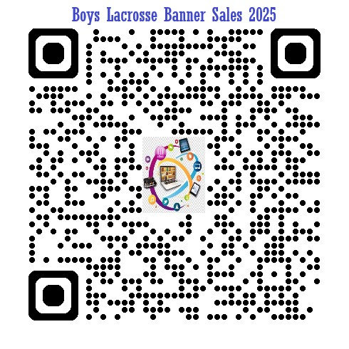

Renew existing banner.

**Banner Questions and artwork submissions:**

**Contact Tom Moon**

**Email:** [**tmoon801@gmail.com**](mailto:tmoon801@gmail.com)

**Call or Text Phone #: 801-633-6333**

**Submit Form, Check (or follow QR code for payment), and Artwork by Friday, February 8th, 2025**

**Thank you for supporting Bingham Boys Lacrosse!**